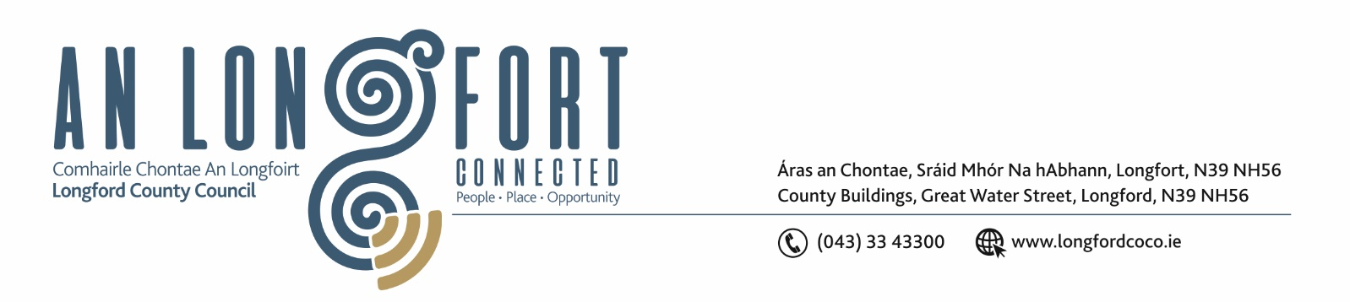

23rd February 2020.

To: Each Member of the Joint Policing Committee.

Re: Meeting of the Joint Policing Committee

Dear Member,

I wish to inform you that the next meeting of the Joint Policing Committee will take place
on Monday, 1st March 2021 at 3.00 p.m. to transact business, as set out on the Agenda hereunder.
Due to the ongoing advice from the HSE regarding the COVID-19 Pandemic, the meeting will be held via Microsoft Teams.

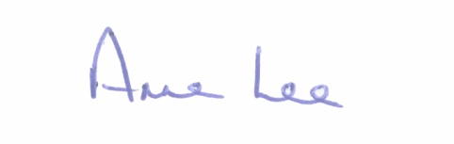
Yours sincerely,

___________________
Anne Lee,
Administrative Officer.

AGENDA

1. Confirmation of Minutes of Joint Policing Committee meeting held on the
7th December 2020 - enclosed.

2. Matters arising.

3. Declaration of Interest by Members.
4. Apologies received.

5. Attendance by representatives from the Department of Justice regarding the establishment of
Local Community Safety Partnership.

6. Garda Report – enclosed.

7. Local Authority Report – enclosed.

8. Consideration of Longford JPC 2020 Annual Report – enclosed.

9. CCTV – Granard and Edgeworthstown.

10. Correspondence – enclosed.

- Correspondence received from the following –
- Office of the Minister for Public Expenditure and Reform and
- Office of the Minister for Justice
regarding request from Longford County Council that monies confiscated under the Proceeds of Crime Acts 1996-2016 be redirected to a local fund for the provision of addiction services, youth activities and other community initiatives to help counter the negative impact of criminality.

11. Date of next meeting- 14th June 2021.



